Motion
Name: ____________________________________ TOTAL

Time allowed for this paper:
Reading time before commencing work:
Working time for paper: 50 minutes

Material required or recommended for this paper

To be provided by the supervisor
This Question/Answer Booklet
Physics: Formulae and Constants Sheet

To be provided by the candidate
Standard Items: Pens, pencils, eraser or correction fluid, ruler.
Special Items: MATHOMAT and/or Mathaid, compass, protractor, set square and calculators satisfying theconditions set by the Curriculum Council for this subject.

Important note to candidates
No other items may be taken into the examination room. It is your responsibility to ensure that you do not have any unauthorised notes or other items of a non-personal nature in the examination room. If you have any unauthorised material with you hand it to the supervisor before reading any further.
Part One: Multiple Choice: 15 Questions
Please do not mark this paper. Answer all questions on the answer sheet.
1. Which of the following is not a vector quantity?
- force
- speed
- acceleration
- displacement

2. The change of distance per unit of time without noting the direction is called:
- velocity.
- speed.
- inertia.
- acceleration.

3. A displacement-time graph shows:
- velocity
- speed
- acceleration
- force

4. Which of the following statements is correct?
- as mass increases, acceleration increases if force is constant
- as mass increases, the force needed to accelerate the object increases
- as mass increases, inertia decreases
- if a force is applied to an object it will accelerate in the opposite direction of the force

5. The acceleration of a car travelling south at a continuous rate of 20 m/s is
a. zero
b. constant, but not zero
c. increasing at a constant rate
d. decreasing at a constant rate

The following information is to be used for questions 6 to 9.
A cart moves along a level bench, and attached to the cart is a long strip of paper which is drawn through a timing device. The timing device makes marks on the paper tape at regular time intervals.
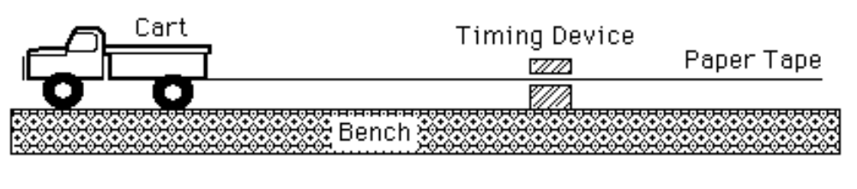
The following diagrams represent the marks made on four separate tapes
by the timing device as the cart moves.
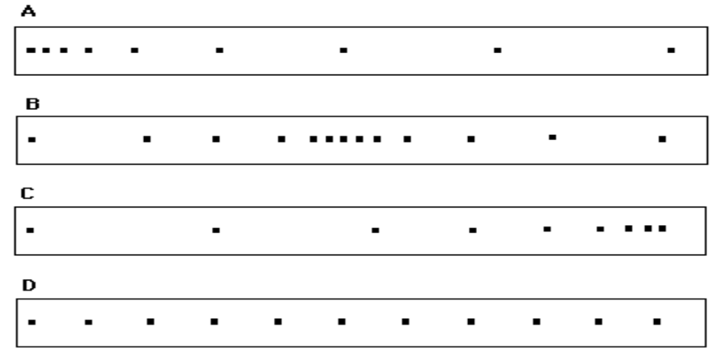
6. Which tape represents the object’s motion for the longest time?
- A
- B
- C
- D

7. Which one of the diagrams best indicates that the cart was slowing down throughout the recorded time interval?
- A.
- B.
- C.
- D.

8. Which one of the diagrams best indicates that the cart started from rest and accelerated?
- A.
- B.
- C.
- D.

9. Which one of the diagrams best indicates that the cart was traveling at constant speed?
- A.
- B.
- C.
- D.

10. The diagram below represents a body moving along a horizontal surface with only two forces affecting its motion, shown as F1( force number one) and F2(force number two).

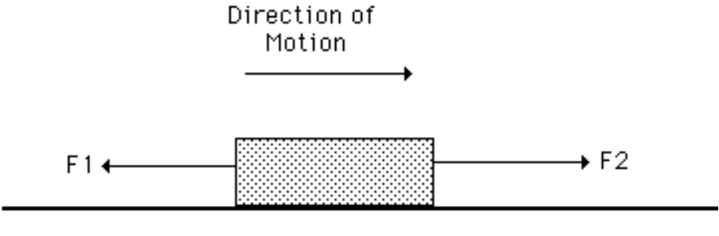

If the body is slowing down, then which one of the following relationships is CORRECT ?
- F1 is greater than F2.
- F1 is less than F2.
- F1 is equal to F2.
- None of the above.

The following information is to be used for questions 11 to 14.
Sir Isaac Newton was responsible for a number of scientific laws, which have now been named after him. Some of these are:
I Newton's First Law of Motion
II Newton's Second Law of Motion
III Newton's Third of Motion
IV Newton's Law of Gravitation
For the following questions choose which law, I, II, III or IV explains the situation.
11. When a car has a head-on collision, a passenger who is not wearing a seat belt may go through the windscreen.
- I.
- II.
- III.
- IV
12. When a rifle is fired, it recoils ('kicks back').
- I.
- II.
- III.
- IV.

13. A car that is fully loaded takes longer to reach 100 km/h from rest than if it had no load
- I.
- II.
- III.
- IV

14. When a car brakes suddenly, packages on a back seat can slide off on to the floor. The continued movement of the packages is due to:
- inertia
- gravity
- friction
- pressure

15. A traffic patrol person stops a cyclist on the Great Eastern Highway coming down the hill and claims the cyclist is doing 70 km/h in a 60 km/h zone.
The cyclist is very surprised and claims to have travelled about 30 km over the past hour and so by his calculation could not possibly be speeding.
Assuming both were reporting what they believed to be true facts, who was right ?
- The cyclist because there was likely to be something wrong with the patrol person's method of measuring speed.
- The patrol person because instantaneous speed is different from average speed
- The cyclist because someone on a push bike is never going to be able to reach 70km/h on a bike.
- The patrol person because the cyclist made an error calculating the average speed as being less than 60 km/h

End of Section A. Please go to Section B

Yr 10 Motion Topic Test
Name:

Section A – 15 Multiple Choice Questions. Please put a cross through the correct answer.
1. A B C D
2. A B C D
3. A B C D
4. A B C D
5. A B C D
6. A B C D
7. A B C D
8. A B C D
9. A B C D
10. A B C D
11. A B C D
12. A B C D
13. A B C D
14. A B C D
15. A B C D
Marks achieved
Multiple choice | /15
Short Answers | /24
Total | /39

PLEASE TURN THIS PAGE OVER FOR SECTION B
Section B: Calculations and Short Answer Questions
Write your answers in the spaces provided. Show all working out and where necessary round your answers to 2 decimal places.
1. A softball has a mass of 500 g
a) At what rate is the ball accelerated towards the batsman if a 69 N force is applied to it in the forward direction? [1 mark]

b) If it took 0.7 s to reach the batsman what was its velocity before contact with the bat? [2 marks]

c) The batsman slips after making contact with the ball. The ball falls to the ground.
What is the deceleration of the ball if it takes 0.2 seconds to reach the ground?
[1 mark]

2. A car moving at 10 m/s East is accelerated at 4 m/s² East. After a period of 5 s, determine the
a) displacement of the car [2 marks]

b) average velocity of the car [1 mark]

c) final velocity of the car. [2 marks]

3. On a school ski trip, a mini-bus transports passengers between the car park and the ski centre. The bus starts from the car park and travels north to the ski centre, drops off the passengers and returns to the car park. The velocity–time graph for the bus journey is given below.
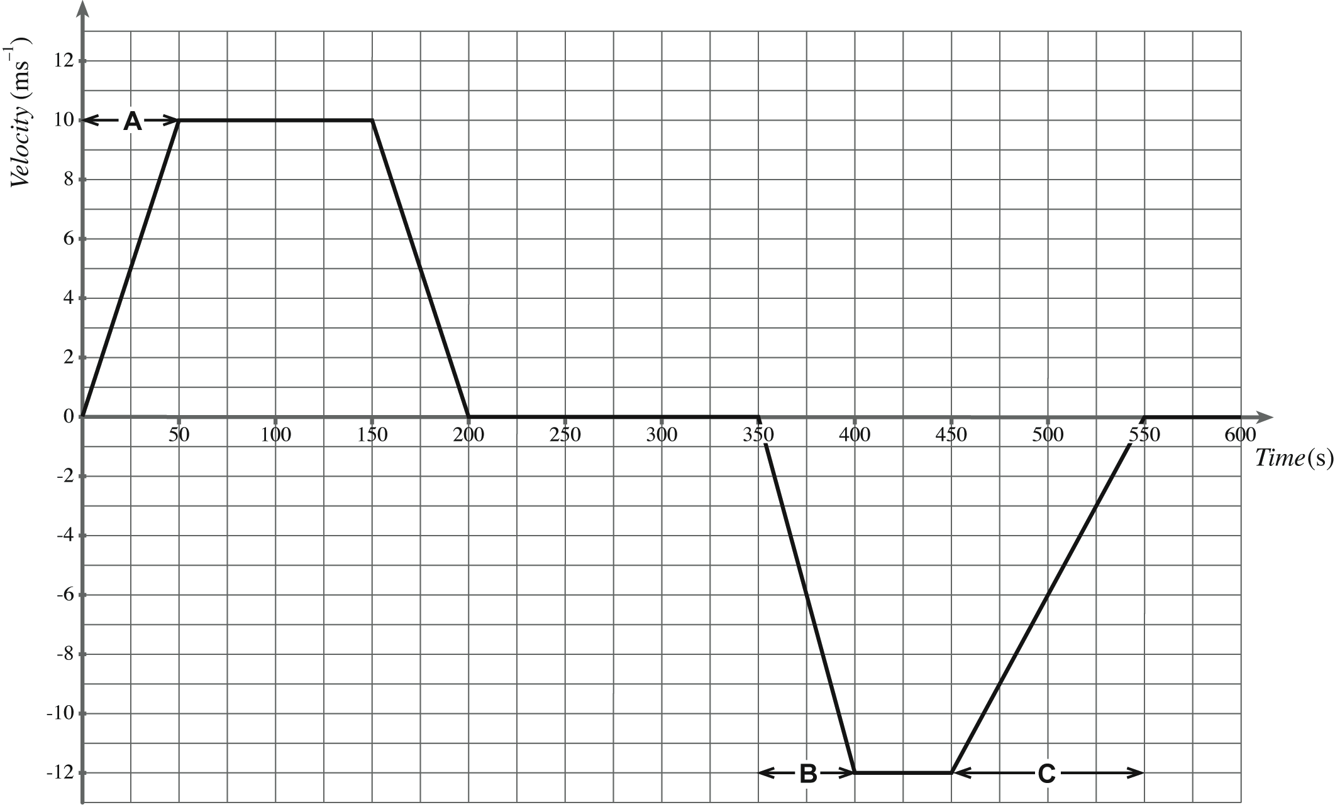
Time (s)
Velocity
(ms⁻¹)

a ) On the graph, label the constant velocity regions of the bus during its journey. [1 mark]

b) The mass of the bus is 2250 kg. The combined mass of the driver and the passengers is
800 kg. Calculate the force required to produce the acceleration of 0.20 m s^{–2}, during section A of its journey. [2marks]

After unloading the passengers at the ski centre, the bus now travels back to the car park with some tourists.
c) Explain why the second part of the graph is drawn below the time axis. [1mark]
d) Describe the motion of the bus during section B of its journey. [1mark]
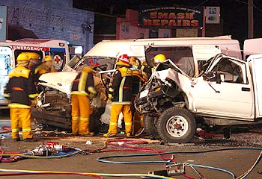

4. Consider the head on accident shown in the picture. A four wheel drive car and its driver have a combined mass of 1200 kg.
The car collided head on with a stationary van of mass 1500 kg.
The car and van locked together after impact and from the marks on the road the police were able to deduce that the wreckage moved at 4.00 m s^{–1} immediately after the collision.
a) Calculate the speed of the car just before it collided with the van. [2marks]
b) Describe two features that a car has in order to reduce injury to the driver during a collision.
[2 marks]

5. A rubber ball strikes a wall head-on at 8.00 ms^{–1}. It rebounds back off the wall with a speed of 5.00 ms^{–1}. The ball has a mass of 0.500 kg. Calculate its change in momentum by finding the change in velocity first? [6 marks]

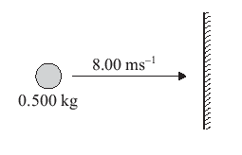

End of Test

